**Requirement Gathering and Analysis Phase**

**Technology Stack (Architecture & Stack)**

|  |  |
| --- | --- |
| Date | 7 July 2024 |
| Team ID | SWTID1720171927 |
| Project Name | Project-SB Foods - Food Order App |
| Maximum Marks | 3 |

**Technical Architecture:**

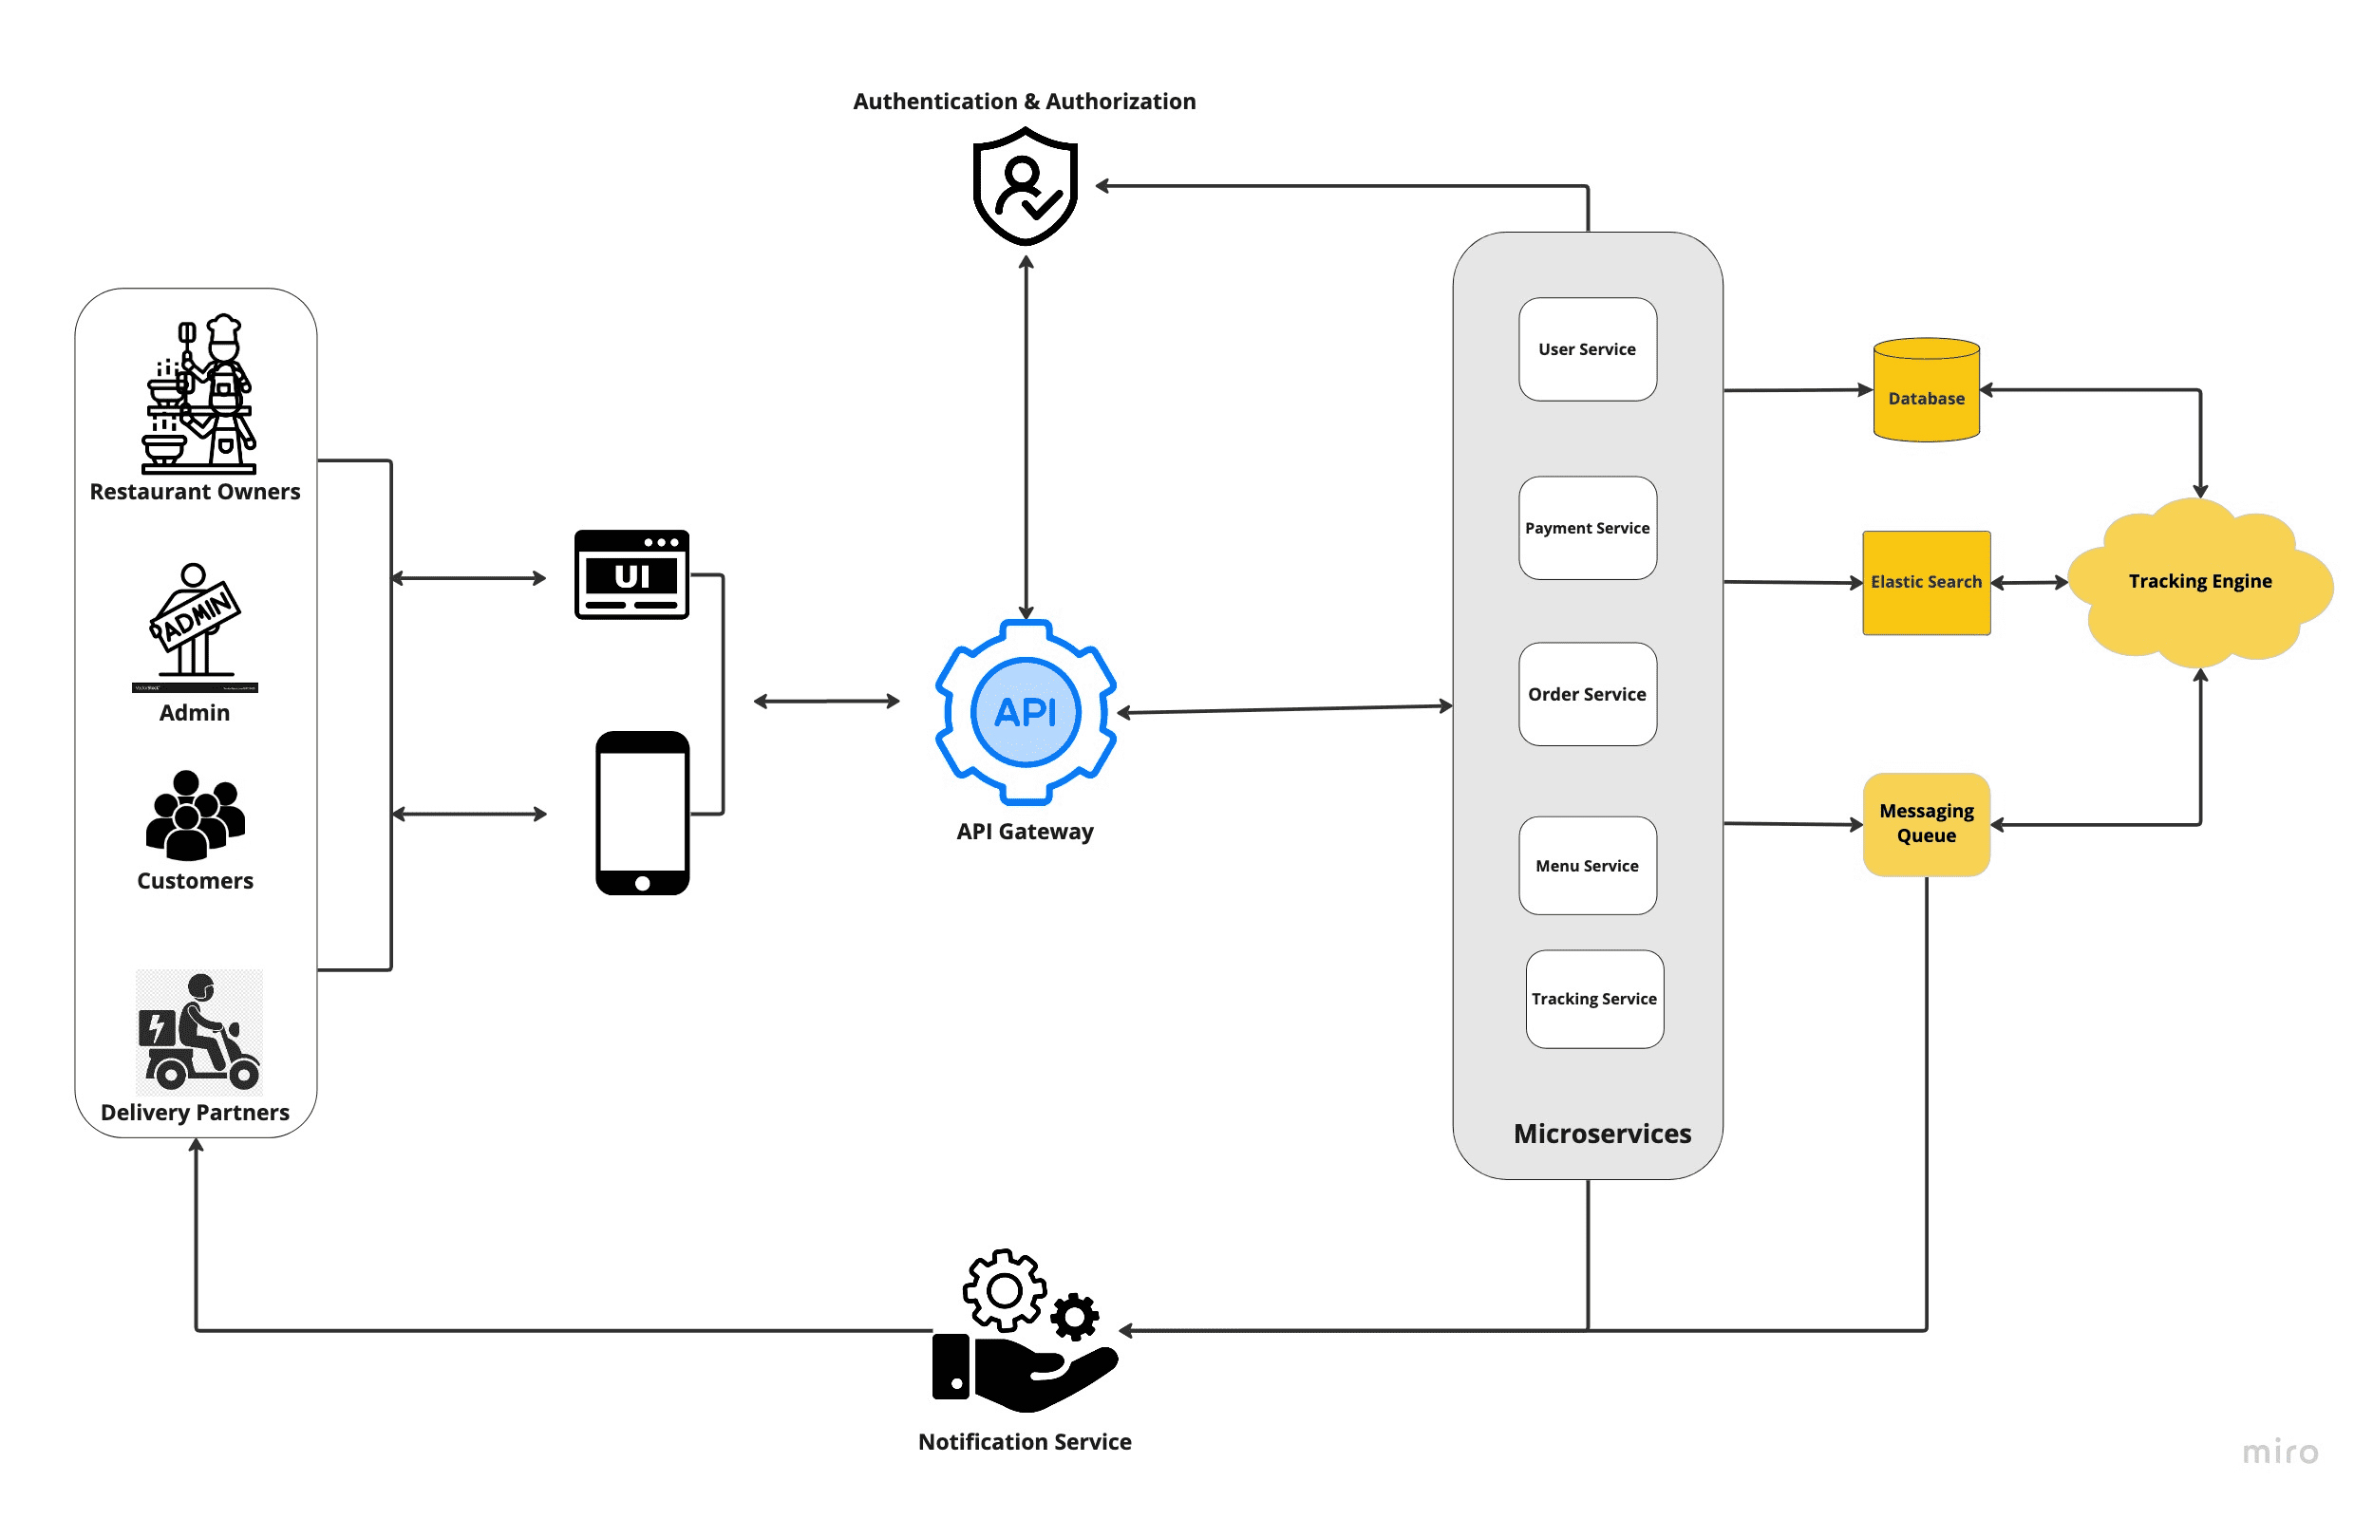

**Table-1 : Components & Technologies:**

|  |  |  |  |
| --- | --- | --- | --- |
| **S.No** | **Component** | **Description** | **Technology** |
| 1 | User Interface | How users interact with the application | HTML, CSS, JavaScript / React.js |
| 2 | Application Logic-1 | Logic for user registration and authentication | Node.js |
| 3 | Application Logic-2 | Logic for managing restaurant operations | Node.js, Express.js |
| 4 | Application Logic-3 | Logic for order processing | Node.js, Express.js |
| 5 | Database | Data storage and retrieval | MongoDB |
| 6 | Cloud Database | Cloud-based database service | MongoDB Atlas (Cloud-hosted MongoDB) |
| 7 | File Storage | Storage for user uploads | Local filesystem or cloud storage service (e.g., AWS S3) |
| 8 | External API-1 | Integration for payment processing | Stripe API |
| 9 | External API-2 | Integration for geolocation services | Google Maps API |
| 10 | Machine Learning Model | Not specified in the provided information | N/A |
| 11 | Infrastructure | Deployment environment | Local server or cloud platform (e.g., AWS, Azure, GCP) |

**Table-2: Application Characteristics:**

|  |  |  |  |
| --- | --- | --- | --- |
| **S.No** | **Characteristics** | **Description** | **Technology** |
| 1 | Open-Source Frameworks | Frameworks or libraries used that are open-source | Node.js, Express.js, React.js |
| 2 | Security Implementations | Security measures implemented | HTTPS, JWT (JSON Web Tokens), bcrypt for password hashing |
| 3 | Scalable Architecture | Architecture design for scalability | Microservices architecture, Docker containers |
| 4 | Availability | Measures to ensure high availability | Load balancing (e.g., with Nginx), redundancy in the database (MongoDB replication) |
| 5 | Performance | Considerations for optimizing application performance | Caching (Redis), CDN (Content Delivery Network) for static assets |